**MoyaLapizzaria application**

I have start to develop the projecf using JSf and after a wjile got conmfused the JSF life cycle. Then I decided to do it using jsp and servlet.

I have used following technology and IDE developing this app:

* Netbean 7.2.1 IDE
* Tomcat server 7.0.24

Netbean uses port 8084 in my machine. Just be aware of it.

To start the application in browser use this link (netbean user): <http://localhost:8084/LapizzeriaMoya1/home.jsp> or

<http://localhost:8080/LapizzeriaMoya1/home.jsp>

When app starts it starts index.jsp and from there calls setup.java servlet that configure and setup hard coded pizzas, users and admin users. then starts home.jsp

There are following scenarios:

* Click **Login** If user is existing user (already registered). Then enter valid username and password. I have hard coded 3 users and 2 admin users ()hard coded in setup.java.
  + User1:
    - userid(email): moya@itu.dk
    - password: abc123
  + User2:
    - userid(email): amin@itu.dk
    - password: abc123
  + User3:
    - userid(email): rado@itu.dk
    - password: abc123
  + Admin User1:
    - userid(email): moya@itu.dk
    - password: abc123
  + Admin User2:
    - userid(email): amin@itu.dk
    - password: abc123

Successfully login forwards users to list of pizza where user can add to basket. There are totally 33 pizzas hard coded and it will be showed list of 10 pizza per page. By clicing next or previous link you can navigate to other pages. After adding pizzas to basket click on basket link and from there you can add extra ingredience or add additional number of the same pizza or even remove pizza from basket. Finally you click to checkout button to proceed your order and you can confirm your order. User gets an confirmation page as thanks for ordering. Then user can start order pizzas again.

Existing user:

Login and shop

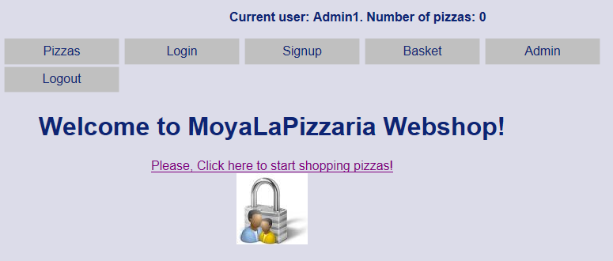

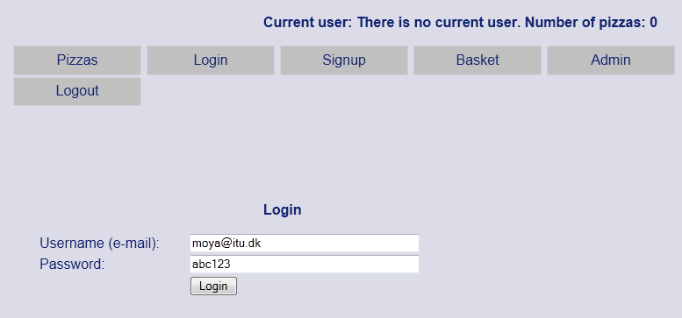

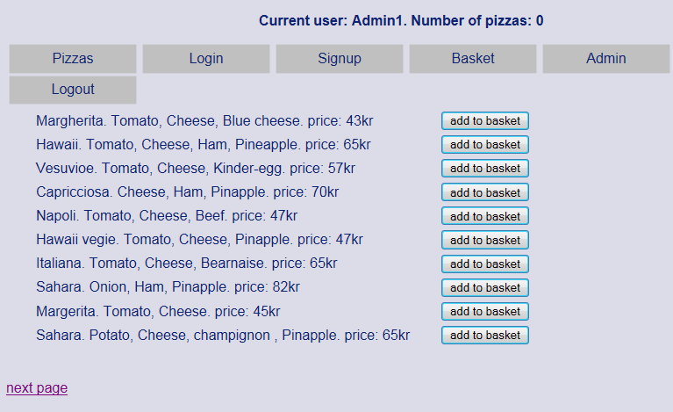

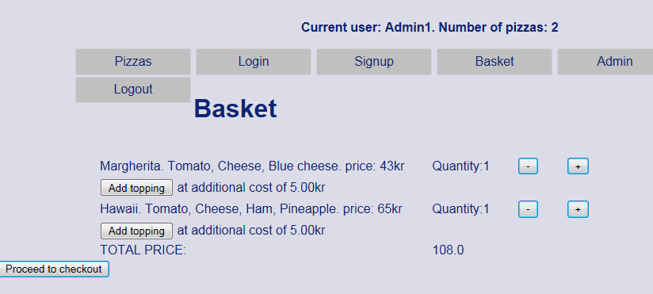

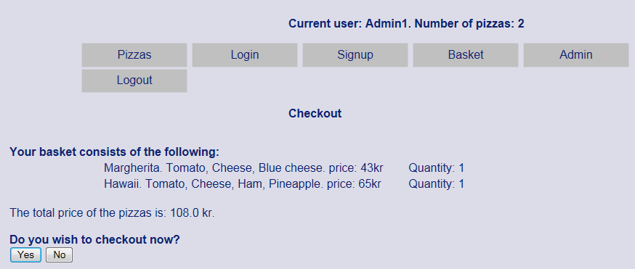

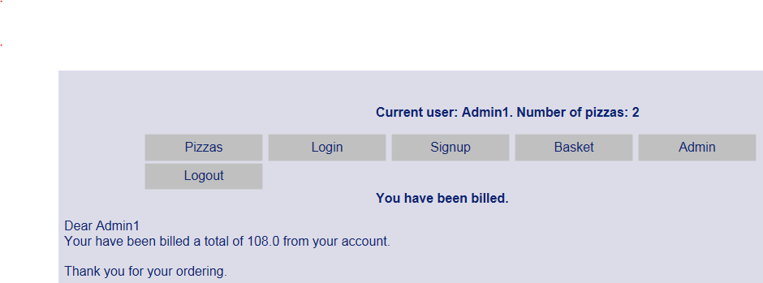

* if user in not already registered and is new user so he/she has to sign up as new user. New user must enter a valid userid(email) like [moya@itu.dk](mailto:moya@itu.dk) , password (like abc123 or far123&), zip code(4 digits Danish zip code between 999..9999) and phone nummer(8 digits). Otherwise will get error message. NB! There is some issue new sign up. Session problem.
* Sign up (new user, not registered user):

Name: far

Username (your e-mail): [far@itu.dk](mailto:far@itu.dk)

Password: far123&

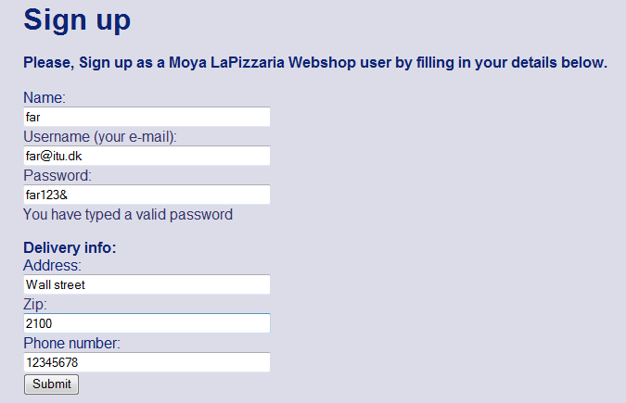

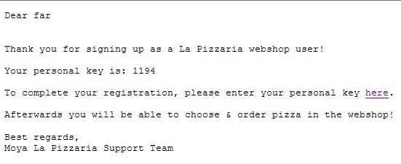

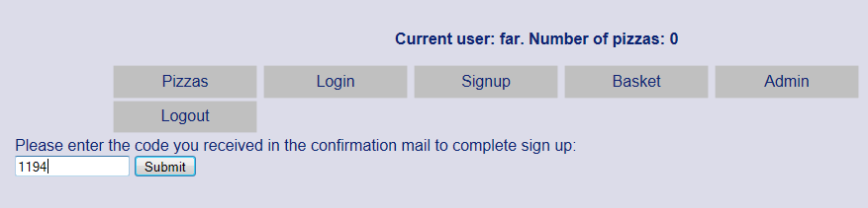

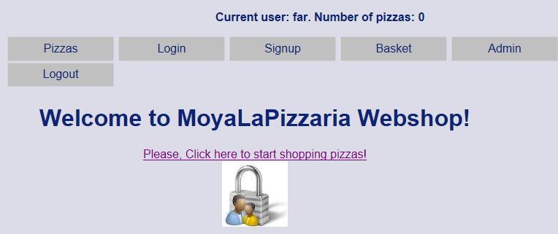

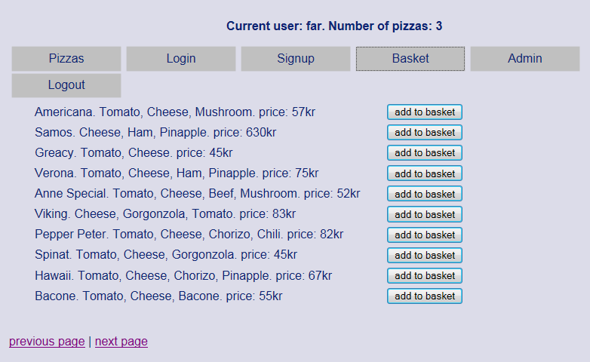

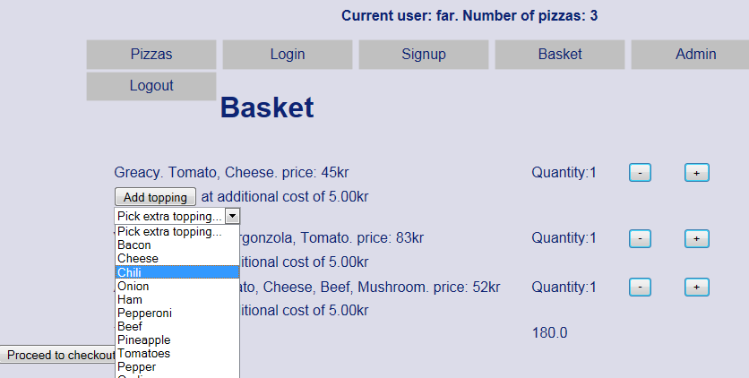

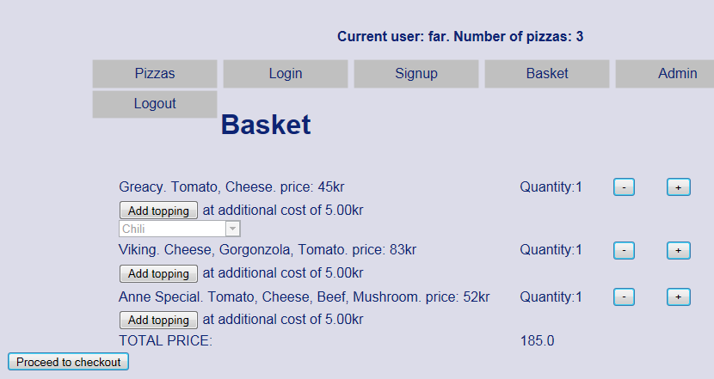

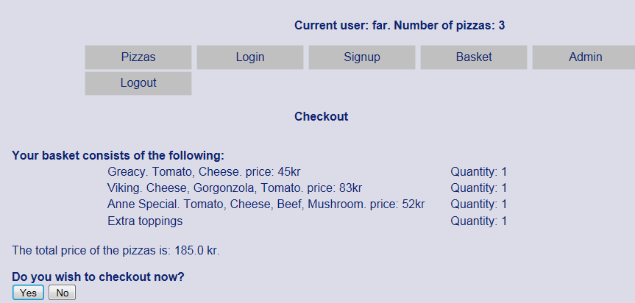

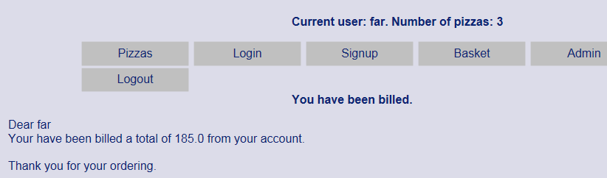

As **Admin** user you can add or remove pizza to or from the list of pizza.   
NB! Sometime there is issue for adding new pizza to the list of pizza. perhaps session problem. It is a part of my ToDo list

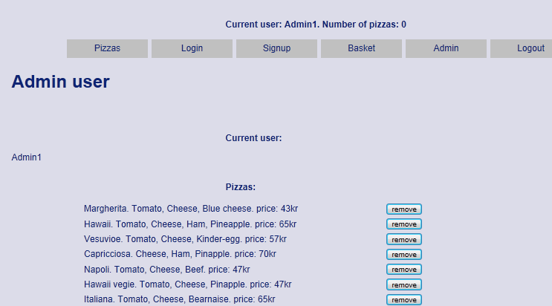  
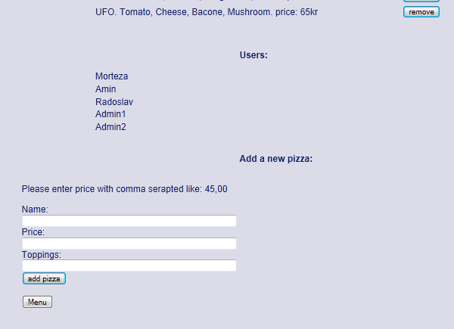

Adding new pizza:

Name: Moya1

Price: 35,00

Toppings: Tomato, Cheese, Squash. Gorgonzola

If click mnenu button the user will be return to home page.